Spring 2025 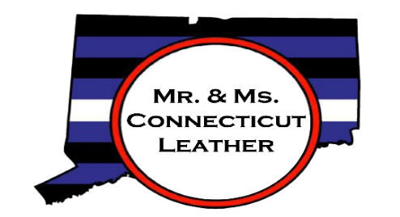
Advertising / Sponsorship Application
Thank you for taking time to look over the advertising and sponsorship information for the
Mr. and Ms. Connecticut Leather 2026 Contest!
This will be the 30th contest for male identified contestants, and the third contest for female identified contestants! We are very excited about what this event has to offer our community and our sponsors - please visit www.mrctleather.org for more information. We know that due to inflation and the current political climate, your organization’s budget may be in flux, as is ours. As an all-volunteer organization, all money donated goes towards our event. Connecticut Leather is asking for your assistance. We promise that your business and/or organization will be publicly recognized for your contributions multiple times in person at the event and also on social media to help promote not only the event weekend, but also to promote the services your organization offers or the products you sell. In addition to financial sponsors, we are also looking for donations of prizes toward our winners package and for raffles.
The Mr. and Ms. Connecticut Leather 2026 Weekend will be held in downtown New Haven, CT the weekend of September 5 through 7, 2025.

With a dedicated and distinguished history, advertising with Connecticut Leather, Inc. will give you the opportunity to reach a significant number of individuals in the Leather, Bear and LGBTQ+ community.
Apply now! Our advertising deadline will approach quickly, and we want to make sure you have the opportunity to reach out to and support this important market!
The deadline for submission of your sponsorship logo and payment is August 1, 2025. The deadline for submission of your program logo/ad copy logo is August 15, 2025.
Please review the advertising application on the following pages and please do not hesitate to contact us if you have any questions.
Sincerely,

Connecticut Leather, Inc.
leather@mrctleather.org
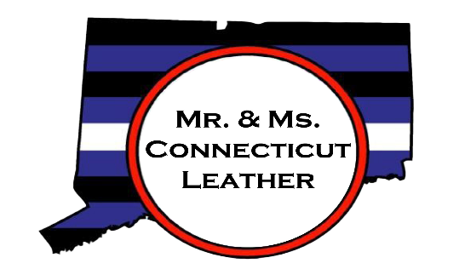
Advertising Information
Name of Business: _________________________________________________________
Contact person: ___________________________________________________________
Contact person’s email: ____________________________________________________
Contact person’s phone: ___________________________________________________
Mailing address: ___________________________________________________________
___________________________________________________________________________

Ads must be 300dpi, JPG or PNG – and must be received with payment by the deadline of August 1, 2025 to be included in program book.
Except for the covers, all advertisements will be in black & white (grayscale) only.

Sponsor Logos, payments and ad payments must be received by August 1, 2025.
Completed ads can be emailed to leather@mrctleather.org or CTLeather2017@gmail.com
Advertising Costs
__________ Gold Sponsor (includes full page ad) $600
__________ Silver Sponsor (includes half page ad) $400
__________ Full page ad $150
__________ Half page ad $100
__________ Business card sized ad $50
__________ Full page BACK COVER COLOR ad (please contact to check availability) $275
__________ Full page INSIDE COVER COLOR ad (please contact to check availability) $250
Please remember to send your logos and payment to arrive before August 1, 2025 for Sponsors and by August 15,
202 f5or ad inclusion in the program. Make checks payable to Connecticut Leather and list the ad name in the memo section. Mail payments to Connecticut Leather, c/o Ian Rosman, 1108 Hanover Ave, Meriden, CT 06451. Contact leather@mrctleather.org or ctleather2017@gmail.com with questions or availability. Advertising is not considered final until payment is received. Connecticut Leather Inc. reserves the right to refuse to publish an advertisement for any reason

Full Page Half Page Business Card

5.5” H x 8.5” V 5.5”H x 4.25” V

In addition to weekend sponsors, we are also accepting in-kind donations of gift baskets, gift cards, or other prizes for our Saturday night raffle during the contest. Additional items can be designated as prizes to the contest winners. If you wish to donate for these opportunities, please contact us.
The names of all sponsors and prize donations will be publicly announced
during the contest!

Leather@mrctleather.org

On Facebook: Connecticut Leather

